Abigail Higham

Political Science 328

Professor Goodliffe

Section 006

Aryanna Hyde

Problem Set 6

Part 3

Code: 9132

Esteemed Department of Health,

For your assistance, I have provided my statistical analysis to aid your policymaking decision regarding if pregnant women’s daily cigarette consumption negatively affects the birthweight of children and if cigarette taxes will decrease pregnant women’s cigarette consumption. My findings conclude that pregnant women’s daily cigarette consumption is associated with a decrease in birthweight, but cigarette taxes do not reduce cigarette consumption. However, there is another strong factor that reduces pregnant women’s daily cigarette consumption, the amount of education years received by the pregnant woman.

For my methodology, I ran statistical tests to evaluate existing relationships between birthweight and pregnant women’s cigarette consumption and between cigarette consumption and cigarette taxes. The statistical tests show me two different important things. First, it indicates the strength of the relationships between the factors. Secondly, it shows if I am missing factors that explain the outcomes that we would like to know more about, such as what else might influence birthweight besides the mother’s cigarette consumption or what also decreases pregnant women’s cigarette consumption besides cigarette tax. The statistical tests that I used were most appropriate, because they properly convey the strength of the relationship between different influences.

My first finding concludes that the number of cigarettes smoked by pregnant mothers has a strong negative impact on the birthweight of her baby. There are other factors that also influence a baby’s birthweight, including its gender, race, and family income, but the genetic factors cannot be as easily adjusted as cigarette consumption per day. Therefore, I recommend that it would be best to try to reduce the amount of cigarettes consumed by pregnant mothers to increase birthweight.

My second finding also show cigarette taxes are not an effective way to try to reduce pregnant women’s daily cigarette consumption. In fact, states with cigarette taxes have a slightly higher cigarette consumption. In the real world, this probably means that pregnant women’s cigarette consumption is not affected by cigarette taxes. However, the years of education that the mother has significantly reduces the amount of cigarettes she will consume. For every year of education that is added to a woman’s education, there is an associated decrease of .434 cigarettes consumed daily. If the proposed policy is primarily concerned for the birthweight of children, I would recommend focusing on increasing the years of education mothers receive. If a women received four more years of education, then I predict she will smoke two less cigarettes per day, which could increase the birthweight.

There are some limitations to my findings. Most of the information that I was given to predict a child’s birthweight had to do with genetics. While these are important factors to help determine birthweight, it limits my ability to suggest and recommend other possible approaches that the policy could adapt to increase birthweight. This doesn’t mean that my findings are incorrect, but it does mean that there could be more undetermined factors that could help increase the average birthweight.

In conclusion, reducing cigarette consumption of pregnant women would help increase birthweight. In order to reduce cigarette consumption, it would be best to increase the number of educational years that mothers receive. Focusing on education rather than cigarette taxes would be significantly more efficient at reducing cigarettes consumed during pregnancy

**APPENDIX**

$$\hat{Birthweight}=112.0653-.4741599(cigarettes consumed per day)$$

*This is controlling for other relevant significant variables that showed a significant p-value, including: Family income, cigarettes consumed per day during pregnancy, gender, and race.

**Graph 1**

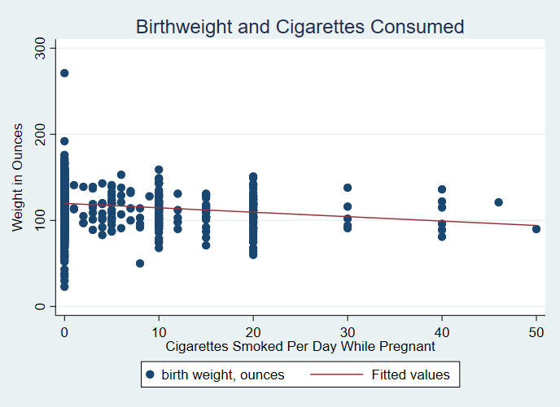

***Graph One****: This chart is showing the association of cigarettes smoked per day while pregnant and birthweight. An increase of one unit of cigarettes smoked per day while pregnant is associated with a .4741599 ounce decrease in birthweight.*

|  |  |
| --- | --- |
|  | (1) |
| VARIABLES | Birthweght |
|  |  |
| Cigarettes Consumed | -0.474*** |
|  | (0.089) |
| Family Income | 0.060** |
|  | (0.030) |
| Male | 3.145*** |
|  | (1.065) |
| White | 5.407*** |
|  | (1.432) |
| Constant | 112.065*** |
|  | (1.452) |
|  |  |
| Observations | 1,388 |
| R-squared | 0.046 |

Robust standard errors in parentheses

*** p<0.01, ** p<0.05, * p<0.1

$$\hat{Cigarettes Consumed}=7.807344+..0254525(cigarette tax)$$

*This is controlling for the other significant variables, including: family income, the education level of the mother, and the education level of the father.

**Graph 2**

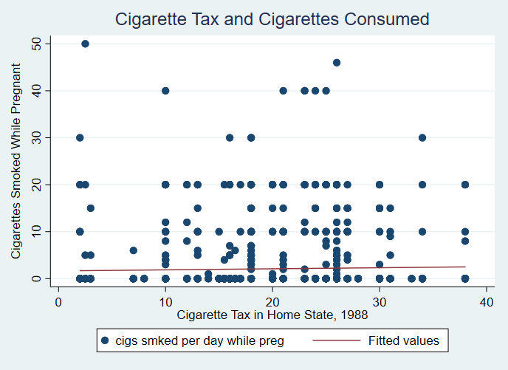

***Graph 2:*** *From this graph, we can see that the amount of cigarettes consumed shows a slight positive correlation with the cigarette tax in the home state. This could be because states with higher rates of cigarette consumption while pregnant are more likely to tax their cigarettes, but there is no clear evidence suggesting that taxing cigarettes will reduce cigarette consumption for pregnant women.*

|  |  |
| --- | --- |
|  | (1) |
| VARIABLES | cigs |
|  |  |
| Cigarette Tax | 0.025 |
|  | (0.019) |
| Family Income | -0.019** |
|  | (0.008) |
| Mother’s Educ | -0.346*** |
|  | (0.096) |
| Fathee’s Educ | -0.104 |
|  | (0.095) |
| Constant | 7.807*** |
|  | (1.117) |
|  |  |
| Observations | 1,191 |
| R-squared | 0.055 |

Robust standard errors in parentheses

*** p<0.01, ** p<0.05, * p<0.1

$$\hat{Cigarettes Consumed}=7.977853-.4344866(years of mother^{'}s education)$$

*This is controlling for other relevant factors that showed a significant p-value (and the cigarette tax), including family income and cigarette tax.

**Graph 3**

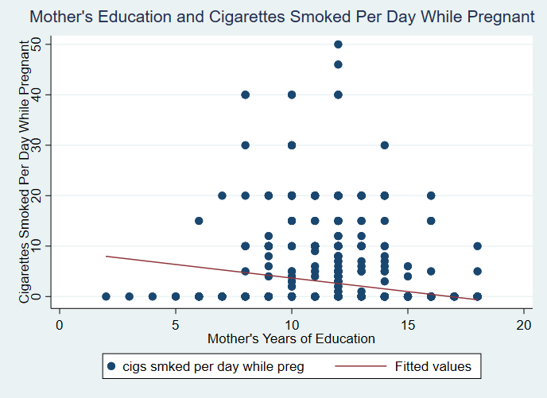  
***Graph 3****: From Graph three, we can see a moderate negative correlation between the years of the mother’s education and the amount of cigarettes the mother’s will consume per day. There is a large standard error, but overall, an increase of one year of the mother’s education will result in a decrease of .434 cigarettes consumed daily. This could significantly impact the baby’s weight.*

|  |  |
| --- | --- |
|  | (1) |
| VARIABLES | cigs |
|  |  |
| motheduc | -0.434*** |
|  | (0.071) |
| cigtax | 0.031 |
|  | (0.021) |
| faminc | -0.030*** |
|  | (0.008) |
| Constant | 7.978*** |
|  | (1.053) |
|  |  |
| Observations | 1,387 |
| R-squared | 0.055 |

Robust standard errors in parentheses

*** p<0.01, ** p<0.05, * p<0.1

**GRADER’S APPENDIX**

**Do File**

**sum**

**scatter bwght packs**

**twoway (scatter bwght packs) (lfit bwght packs)**

**regress bwght packs, robust**

**regress bwght cigs faminc male white, robust**

**ssc install outreg2**

**outreg2 using regression1.doc, word dec(3)**

**twoway (scatter packs cigtax) (lfit packs cigtax)**

**regress cigs cigtax faminc motheduc fatheduc, robust**

**outreg2 using regression2.doc, word dec(3)**

**regress cigs cigtax faminc motheduc fatheduc, robust**

**twoway (scatter cigs motheduc) (lfit cigs motheduc)**

**regress cigs motheduc cigtax faminc, robust**

**outreg2 using regression3.doc, word dec(3)**

**log close**

**Log File**

**___ ____ ____ ____ ____ (R)**

**/__ / ____/ / ____/**

**___/ / /___/ / /___/ 15.1 Copyright 1985-2017 StataCorp LLC**

**Statistics/Data Analysis StataCorp**

**4905 Lakeway Drive**

**Special Edition College Station, Texas 77845 USA**

**800-STATA-PC http://www.stata.com**

**979-696-4600 stata@stata.com**

**979-696-4601 (fax)**

**154-user Stata network license expires 4 Feb 2019:**

**Serial number: 401509206196**

**Licensed to: Brigham Young University**

**Brigham Young University**

**Notes:**

**1. Unicode is supported; see help unicode_advice.**

**2. Maximum number of variables is set to 5000; see help set_maxvar.**

**. use "C:\Users\ahigham4\Downloads\BWGHT.DTA"**

**. do "C:\Users\ahigham4\AppData\Local\Temp\STD1e48_000000.tmp"**

**. scatter bwght packs**

**.**

**end of do-file**

**. do "C:\Users\ahigham4\AppData\Local\Temp\STD1e48_000000.tmp"**

**. twoway (scatter bwght packs) (lfit bwght packs)**

**.**

**end of do-file**

**. do "C:\Users\ahigham4\AppData\Local\Temp\STD1e48_000000.tmp"**

**. regress bwght packs, robust**

**Linear regression Number of obs = 1,388**

**F(1, 1386) = 34.29**

**Prob > F = 0.0000**

**R-squared = 0.0227**

**Root MSE = 20.129**

**------------------------------------------------------------------------------**

**| Robust**

**bwght | Coef. Std. Err. t P>|t| [95% Conf. Interval]**

**-------------+----------------------------------------------------------------**

**packs | -10.27544 1.754668 -5.86 0.000 -13.71753 -6.83335**

**_cons | 119.7719 .5745494 208.46 0.000 118.6448 120.899**

**------------------------------------------------------------------------------**

**.**

**end of do-file**

**. do "C:\Users\ahigham4\AppData\Local\Temp\STD1e48_000000.tmp"**

**. regress bwght cigs faminc male white, robust**

**Linear regression Number of obs = 1,388**

**F(4, 1383) = 18.06**

**Prob > F = 0.0000**

**R-squared = 0.0465**

**Root MSE = 19.904**

**------------------------------------------------------------------------------**

**| Robust**

**bwght | Coef. Std. Err. t P>|t| [95% Conf. Interval]**

**-------------+----------------------------------------------------------------**

**cigs | -.4741599 .0894423 -5.30 0.000 -.6496173 -.2987026**

**faminc | .0600548 .0296573 2.02 0.043 .0018766 .1182331**

**male | 3.14524 1.065271 2.95 0.003 1.055519 5.234961**

**white | 5.407262 1.431944 3.78 0.000 2.598244 8.216279**

**_cons | 112.0653 1.451684 77.20 0.000 109.2175 114.913**

**------------------------------------------------------------------------------**

**.**

**end of do-file**

**. do "C:\Users\ahigham4\AppData\Local\Temp\STD1e48_000000.tmp"**

**. ssc install outreg2**

**checking outreg2 consistency and verifying not already installed...**

**all files already exist and are up to date.**

**.**

**end of do-file**

**. do "C:\Users\ahigham4\AppData\Local\Temp\STD1e48_000000.tmp"**

**. outreg2 using regression1.doc, word dec(3)**

**regression1.doc**

**dir : seeout**

**.**

**end of do-file**

**. do "C:\Users\ahigham4\AppData\Local\Temp\STD1e48_000000.tmp"**

**. twoway (scatter packs cigtax) (lfit packs cigtax)**

**.**

**end of do-file**

**. do "C:\Users\ahigham4\AppData\Local\Temp\STD1e48_000000.tmp"**

**. regress cigs cigtax faminc motheduc fatheduc, robust**

**Linear regression Number of obs = 1,191**

**F(4, 1186) = 14.17**

**Prob > F = 0.0000**

**R-squared = 0.0546**

**Root MSE = 5.2047**

**------------------------------------------------------------------------------**

**| Robust**

**cigs | Coef. Std. Err. t P>|t| [95% Conf. Interval]**

**-------------+----------------------------------------------------------------**

**cigtax | .0254525 .0186211 1.37 0.172 -.0110813 .0619864**

**faminc | -.0194933 .0077072 -2.53 0.012 -.0346145 -.0043721**

**motheduc | -.3456693 .0955787 -3.62 0.000 -.5331915 -.158147**

**fatheduc | -.1040215 .0947606 -1.10 0.273 -.2899387 .0818957**

**_cons | 7.807344 1.117236 6.99 0.000 5.615365 9.999323**

**------------------------------------------------------------------------------**

**.**

**end of do-file**

**. do "C:\Users\ahigham4\AppData\Local\Temp\STD1e48_000000.tmp"**

**. outreg2 using regression2.doc, word dec(3)**

**regression2.doc**

**dir : seeout**

**.**

**end of do-file**

**. do "C:\Users\ahigham4\AppData\Local\Temp\STD1e48_000000.tmp"**

**. regress cigs cigtax faminc motheduc fatheduc, robust**

**Linear regression Number of obs = 1,191**

**F(4, 1186) = 14.17**

**Prob > F = 0.0000**

**R-squared = 0.0546**

**Root MSE = 5.2047**

**------------------------------------------------------------------------------**

**| Robust**

**cigs | Coef. Std. Err. t P>|t| [95% Conf. Interval]**

**-------------+----------------------------------------------------------------**

**cigtax | .0254525 .0186211 1.37 0.172 -.0110813 .0619864**

**faminc | -.0194933 .0077072 -2.53 0.012 -.0346145 -.0043721**

**motheduc | -.3456693 .0955787 -3.62 0.000 -.5331915 -.158147**

**fatheduc | -.1040215 .0947606 -1.10 0.273 -.2899387 .0818957**

**_cons | 7.807344 1.117236 6.99 0.000 5.615365 9.999323**

**------------------------------------------------------------------------------**

**.**

**end of do-file**

**. do "C:\Users\ahigham4\AppData\Local\Temp\STD1e48_000000.tmp"**

**. twoway (scatter cigs motheduc) (lfit cigs motheduc)**

**.**

**end of do-file**

**. do "C:\Users\ahigham4\AppData\Local\Temp\STD1e48_000000.tmp"**

**. regress cigs motheduc cigtax faminc, robust**

**Linear regression Number of obs = 1,387**

**F(3, 1383) = 25.93**

**Prob > F = 0.0000**

**R-squared = 0.0547**

**Root MSE = 5.8152**

**------------------------------------------------------------------------------**

**| Robust**

**cigs | Coef. Std. Err. t P>|t| [95% Conf. Interval]**

**-------------+----------------------------------------------------------------**

**motheduc | -.4344866 .0713397 -6.09 0.000 -.5744324 -.2945409**

**cigtax | .0313874 .0208193 1.51 0.132 -.0094534 .0722283**

**faminc | -.0303923 .0077838 -3.90 0.000 -.0456616 -.015123**

**_cons | 7.977853 1.053488 7.57 0.000 5.911245 10.04446**

**------------------------------------------------------------------------------**

**.**

**end of do-file**

**. do "C:\Users\ahigham4\AppData\Local\Temp\STD1e48_000000.tmp"**

**. outreg2 using regression3.doc, word dec(3)**

**r(608);**

**end of do-file**

**r(608);**

**. do "C:\Users\ahigham4\AppData\Local\Temp\STD1e48_000000.tmp"**

**. log close**

**r(606);**

**end of do-file**

**r(606);**

**.**